# Name: Apurba Koirala

# Reg no: 22BCE3799

# Subject Code: BCSE302L

# Course Title: Database Systems

# Guided by: Dr. Shashank Mouli Satapathy

# Theory Digital Assignment on MONGODB

**Unit 1:**

Unit wise learning: In the MongoDB course, I received a basic introduction to MongoDB, which covered its core concepts and features. The MongoDB team explained how the course would be structured and outlined the various tools used to support the learning process. These tools included Labs for hands-on practice, Quizzes to test knowledge, and a system of Points and Badges to track progress and reward achievements.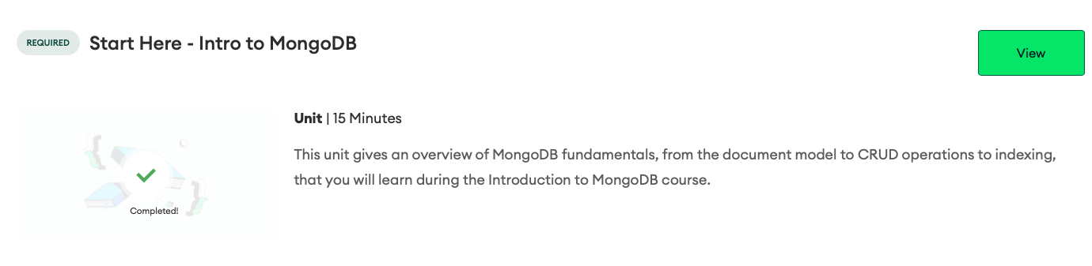

**

**Unit 2:**

Unit Wise learning: In this unit, I explored MongoDB Atlas, a developer data platform designed for managing data within Atlas clusters—a global, multi-cloud database service. The platform provides various features enabling developers to build diverse applications. I created and deployed my first Atlas cluster and prepared for connectivity by configuring a database user, setting a password, and adding an IP address to the IP Access list.

Email Attachment:

**Unit 3:**

Unit wise learning:

This chapter introduced MongoDB as a versatile, document-based database that integrates with Atlas, a developer data platform. It covered MongoDB’s document model, where data is stored in BSON format, supporting various data types and allowing for flexible schemas within collections. Each document requires a unique `_id` field, with MongoDB auto-generating one if missing. The Atlas Data Explorer was highlighted as a tool for creating and managing databases, collections, and documents. Key resources further explained MongoDB’s structure, BSON, and database management functions.

Completion Certificate:

Email Attachment:

**Unit 4:**

Unit wise learning: In this unit, I learned to connect to a MongoDB database on Atlas using three main methods: MongoDB Shell, MongoDB Compass, and applications. Additionally, the unit covered common connection issues and troubleshooting techniques. Key resources included instructions on using connection strings, connecting with various tools, and resolving connection errors.

Completion Certificate

**Unit 5:**

Unit wise learning: In this unit, I learned to insert and retrieve documents in MongoDB using key CRUD operations. I practiced using comparison operators like `$gt`, `$lt`, `$lte`, and `$gte` and logical operators such as `$and` and `$or` to build queries. Additionally, I explored querying array elements with the `$elemMatch` operator.

Completion Certificate

Email Attachment:

**Unit 6:**

Unit Wise Learning:

In this unit, I learned how to modify MongoDB query results. Specifically, I practiced using cursor.sort() to return results in a specified order and cursor.limit() to constrain the number of results. I also learned how to use a projection document in db.collection.find() to specify which fields to return. Additionally, I explored how to count the number of documents matching a query using db.collection.countDocuments().

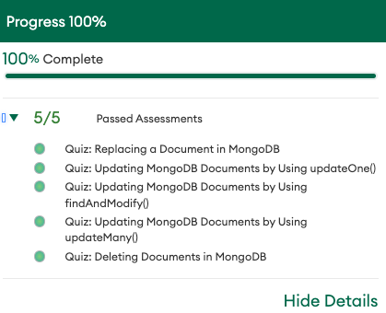

Email Attachment:

**Unit 7:**

Unit wise learning:

In this unit, I learned how to modify MongoDB query results in various ways. I explored how to return query results in a specific order using cursor.sort() and limit the number of results with cursor.limit(). I also learned how to use projection to specify which fields to return in a query by adding a projection document in db.collection.find(). Additionally, I discovered how to count the number of documents that match a query with db.collection.countDocuments().

Completion Certificate: 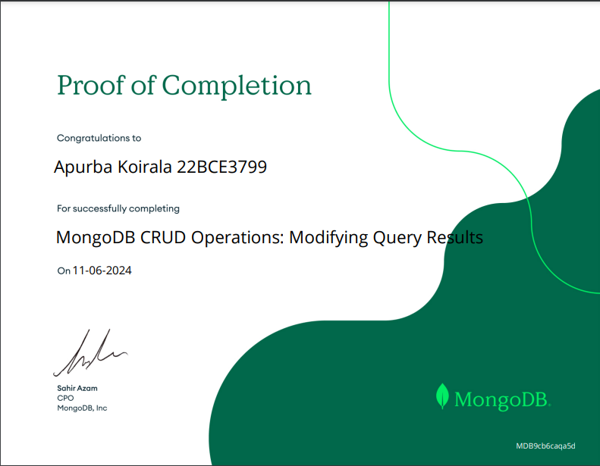

Unit wise learning: In this unit, I learned how to use aggregation in MongoDB to process and analyze data. I explored the creation of aggregation pipelines, which allow for complex data transformations. I worked with several common aggregation stages, such as $match for filtering, $group for grouping data, $sort and $limit for ordering and limiting results, and $project for reshaping documents. I also learned about the $count, $set, and $out stages for counting, modifying documents, and exporting results to another collection.

Email Attachment: 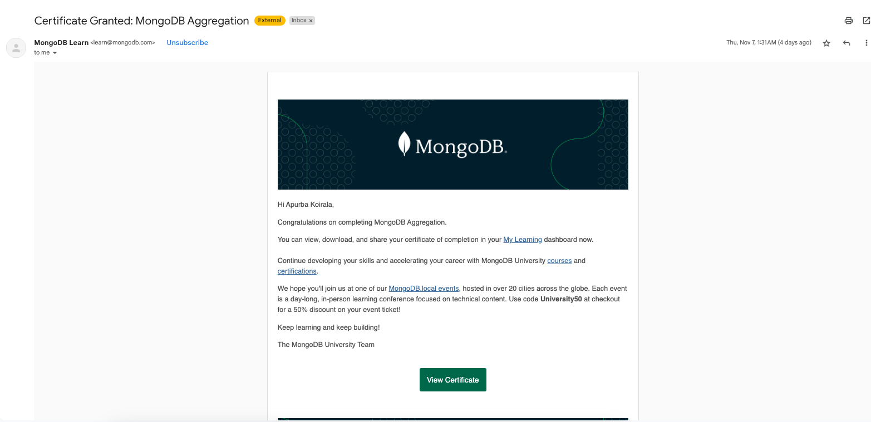

Unit wise learning: In this unit, I learned about MongoDB indexes and how they enhance query performance. I explored different types of indexes, including single-field indexes (for one field) and compound indexes (for 2 to 32 fields). I also worked with multikey indexes, which index array fields. I practiced creating and deleting indexes using the createIndex() and dropIndex() commands. Additionally, I learned how to view the indexes in a collection with the getIndexes() command and how to check if an index is being used in a query using the explain() command.

Completion Certificate: 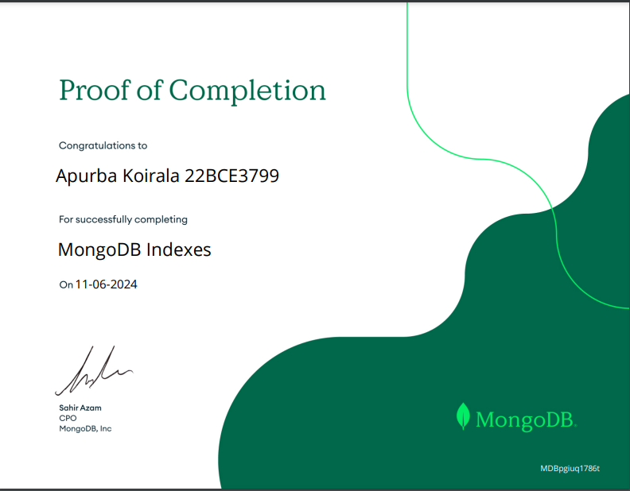

Unit wise learning: In this unit, I learned about Atlas Search, a powerful feature in MongoDB that enables advanced search functionality in applications. I explored how to create search indexes, both dynamically mapped (to search across any field) and statically mapped (to focus on relevant fields). I practiced using the aggregation pipeline with the $search operator to perform searches and compound operators to combine multiple search criteria. Additionally, I learned how to adjust search relevance by assigning different weights to fields and how to use $searchMeta and $facet to categorize search results and improve user experience in apps.

Unit wise learning: In this unit, I learned the fundamentals of MongoDB data modeling, including the purpose of data modeling and the different types of data relationships such as one-to-one, one-to-many, and many-to-many. I explored how to model these relationships effectively, as well as the differences between embedded and referenced data models. I also gained insight into how to scale data models for performance and scalability. Additionally, I learned how to use Atlas tools to assist with schema design and identify common schema design pitfalls.

Completion Certificate: 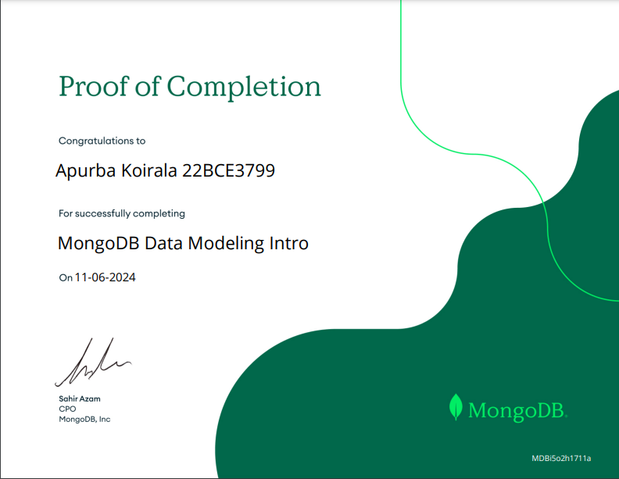

Unit wise learning: In this unit, I learned about ACID transactions in MongoDB, which ensure that database operations are reliable by following the principles of Atomicity, Consistency, Isolation, and Durability. These transactions are important for scenarios like transferring funds between accounts, ensuring that all operations occur together or not at all. I explored how ACID transactions work with MongoDB's document model and how to create multi-document transactions using startTransaction() and commitTransaction(). I also learned how to cancel transactions with abortTransaction().

**Final Completion Certificate:**

**Final Email Attachment:**

